

**Topic : AI-Powered Animal Detection with Custom Vision**

**Report**

**Submitted by :**

Saniya Wagh

2021-B-16052003A

**Group Names :**

Saniya Wagh

Rohan Siddu Samudrala

Lekha Ahirrao

Swapnali Gavali

Anvesh Hirve

Presented to :

Abhay Dhanmeher

Program Trainee

**Overview:**

This project aims to classify Animals based on their types using Azure's Custom Vision, an image recognition service that leverages machine learning. By training a custom classification model, the system can accurately determine which type of animal it is. The goal is to assist industries such as wild photography , zoology, etc...

**Procedure :**

Opened Visual Studio Code after opening, I cloned the repository to a local folder **https://github.com/MicrosoftLearning/AI-102-AIEngineer**

After cloning i opened the Azure portal at **https://portal.azure.com**, and sign in using the Microsoft account with Azure subscription. Selected the **Create a resource** button, and search for

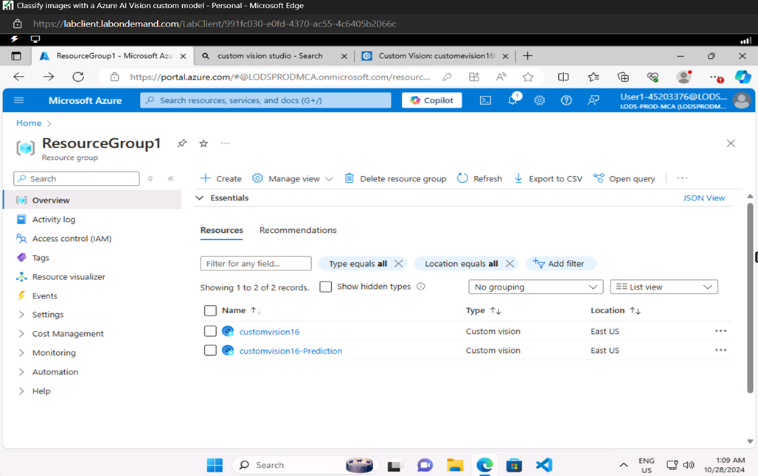

After creating a resource, In a new browser tab, opened the Custom Vision portal at https://customvision.ai signed in using the Microsoft account with Azure subscription In the Custom Vision portal, created a new project with the following settings:

* Name: Animal
* Description: Animal Detection
* Resource: The Custom Vision resource you created previously
* Project Types Classification
* Classification Types Multiclass (single tag per image)
* Domains: Animal
* In the new project, clicked on [+] Add images, and select all of the files in the **training-images** Then uploaded the image files which contains different types of animal.
* After labeling and uploading In the Custom Vision project, trained a classification model using the tagged images. Selected the **Quick Training** option, and then waited for the training iteration to complete
* When the model iteration has been trained, reviewed the *Precision*, *Recall*, and *AP* performance metrics - the prediction accuracy of the classification model was high.

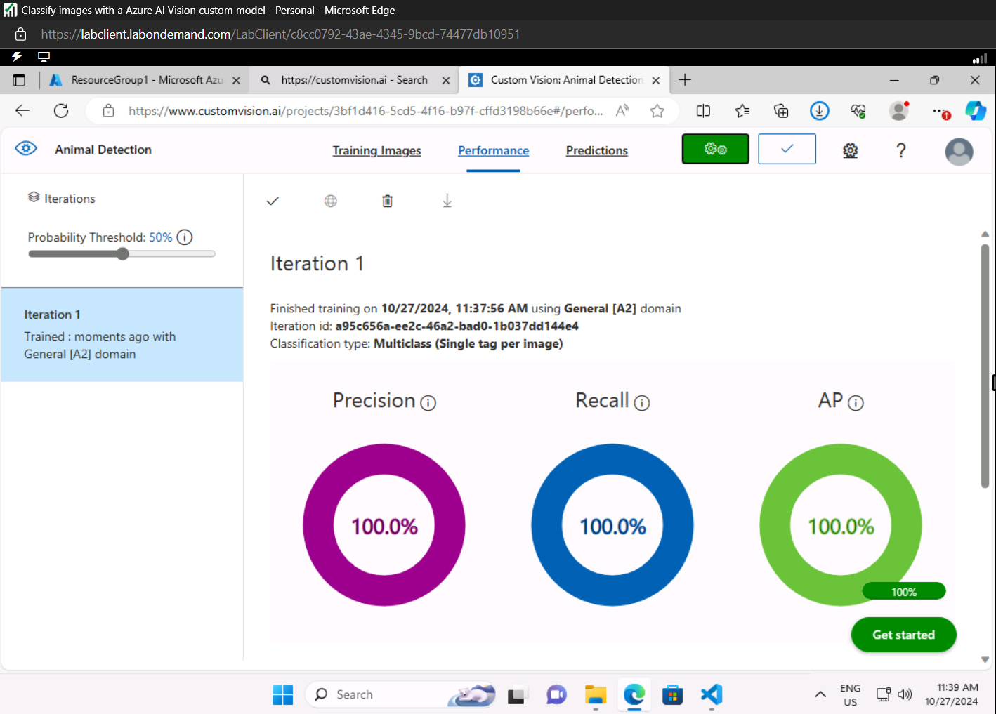

Tasted Model :-

Following are the output of the trained Model :-

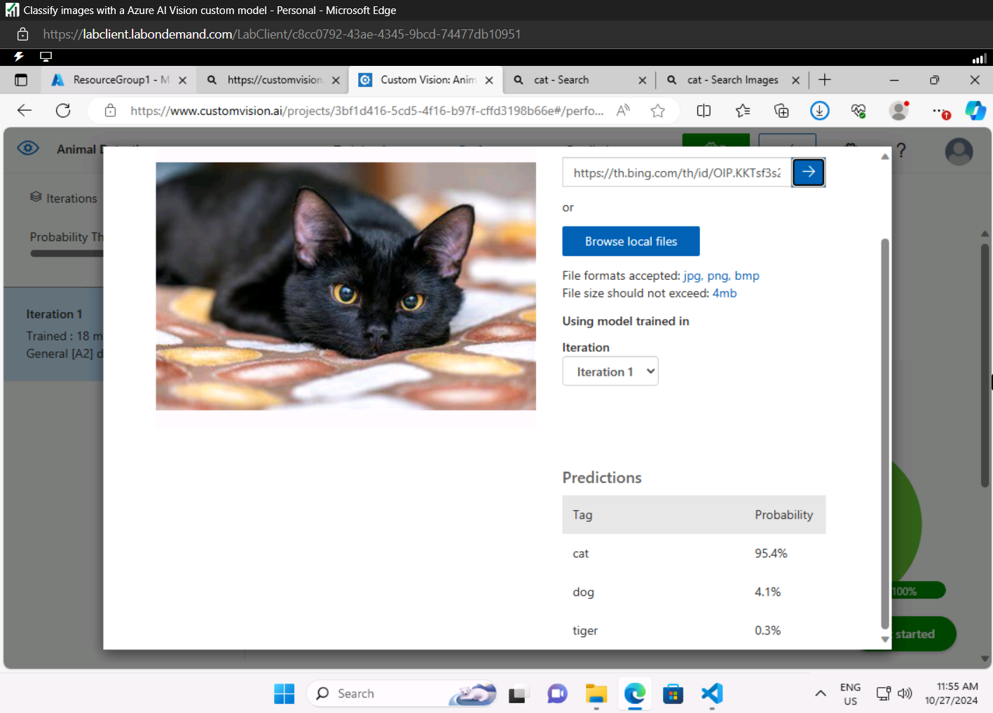

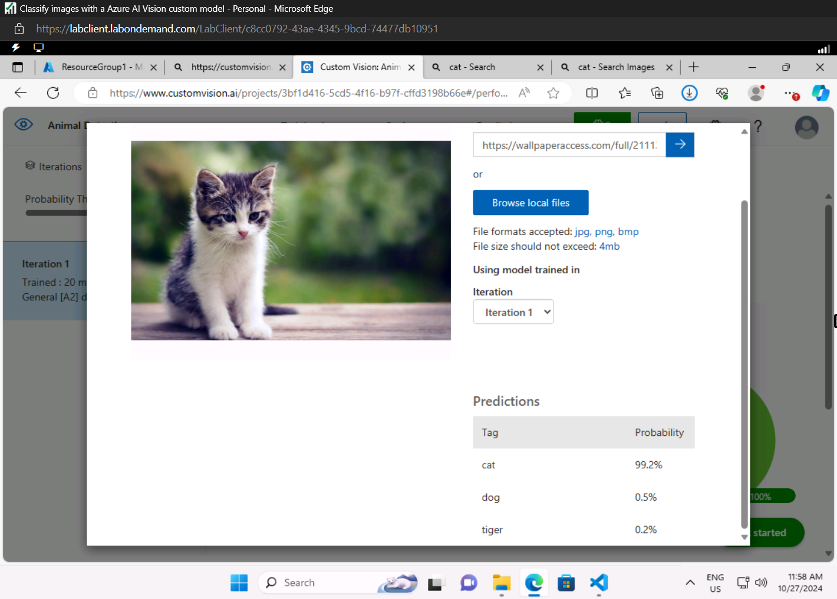

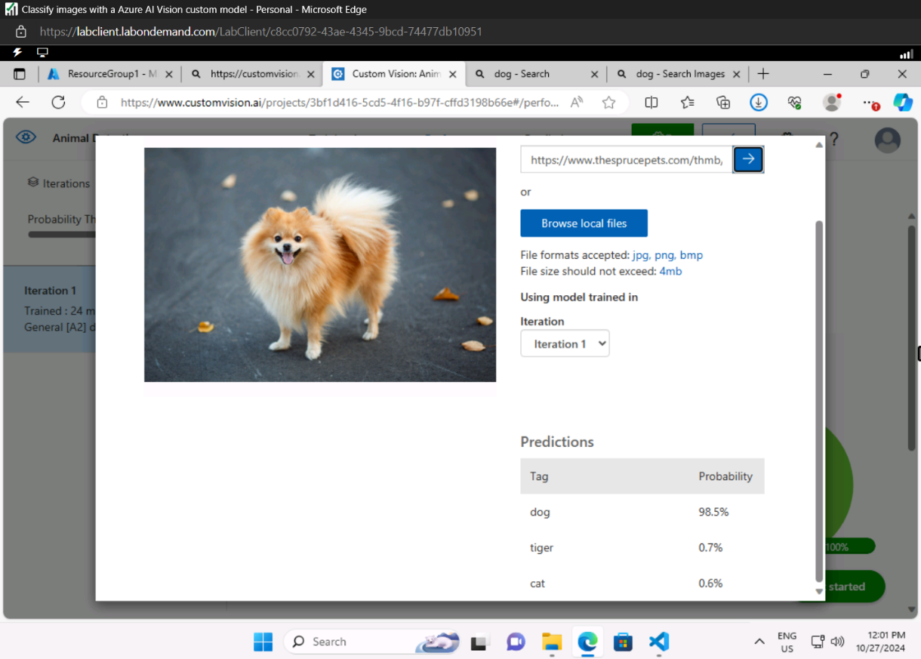

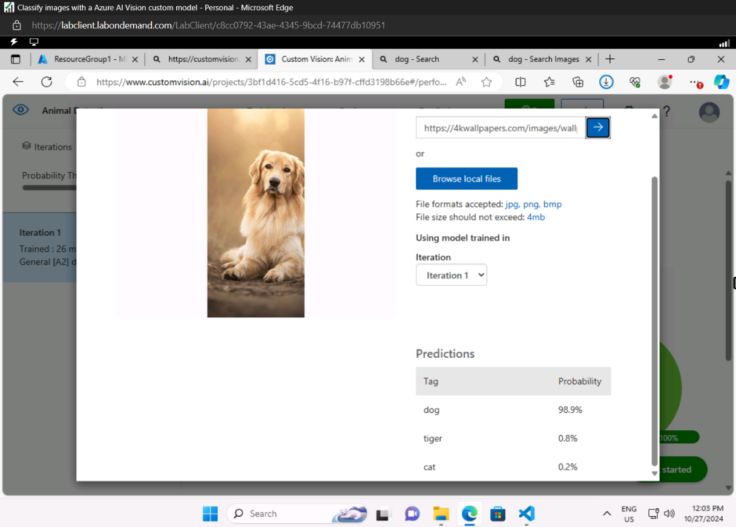

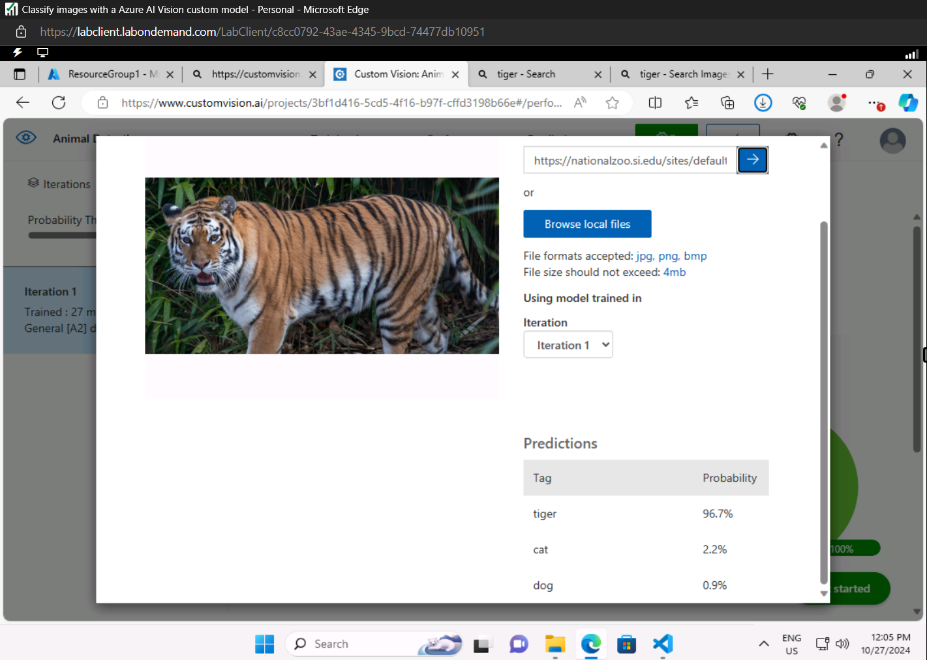

# Using the *training* API

* In Visual Studio Code, in the **Explorer** pane, to the **17-image_classification** folder and expand the **Python** folder.
* Right-clicked the **train-classifier** folder and open an integrated terminal. Then install the Custom Vision Training package
* In this lab i have used python programming so according to that i installed custom vision training package

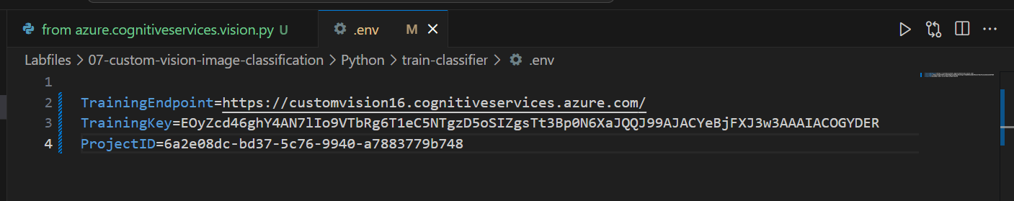

After saving the configuration

## Python Program (train-classifier.py) :-

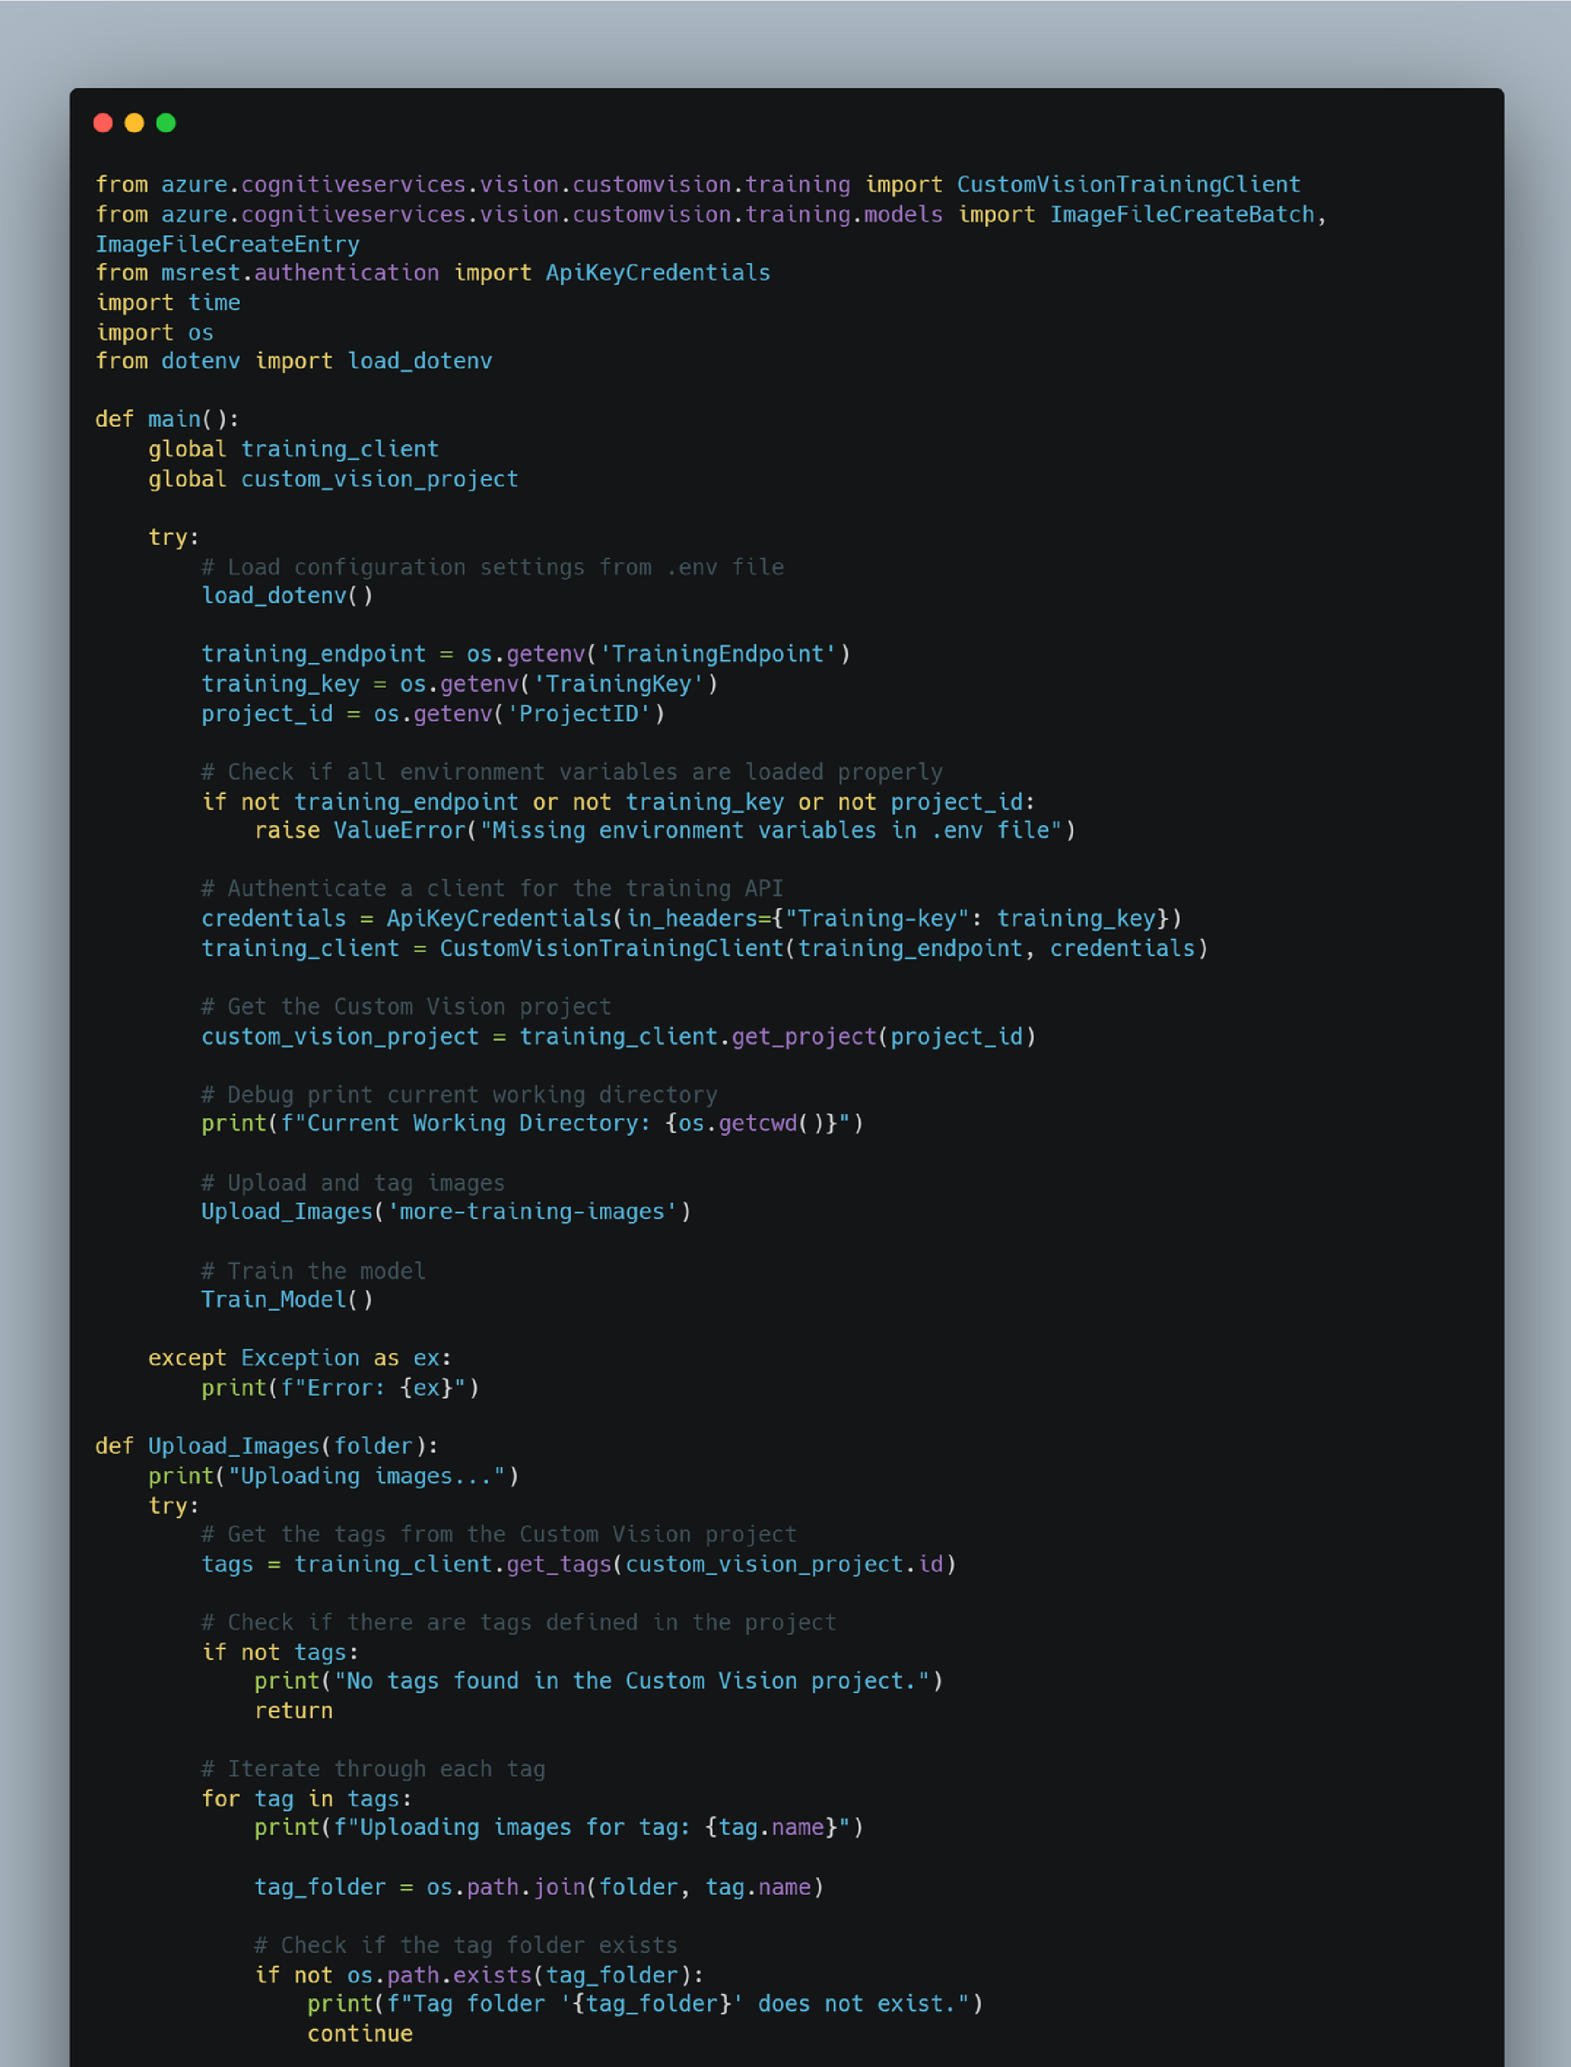

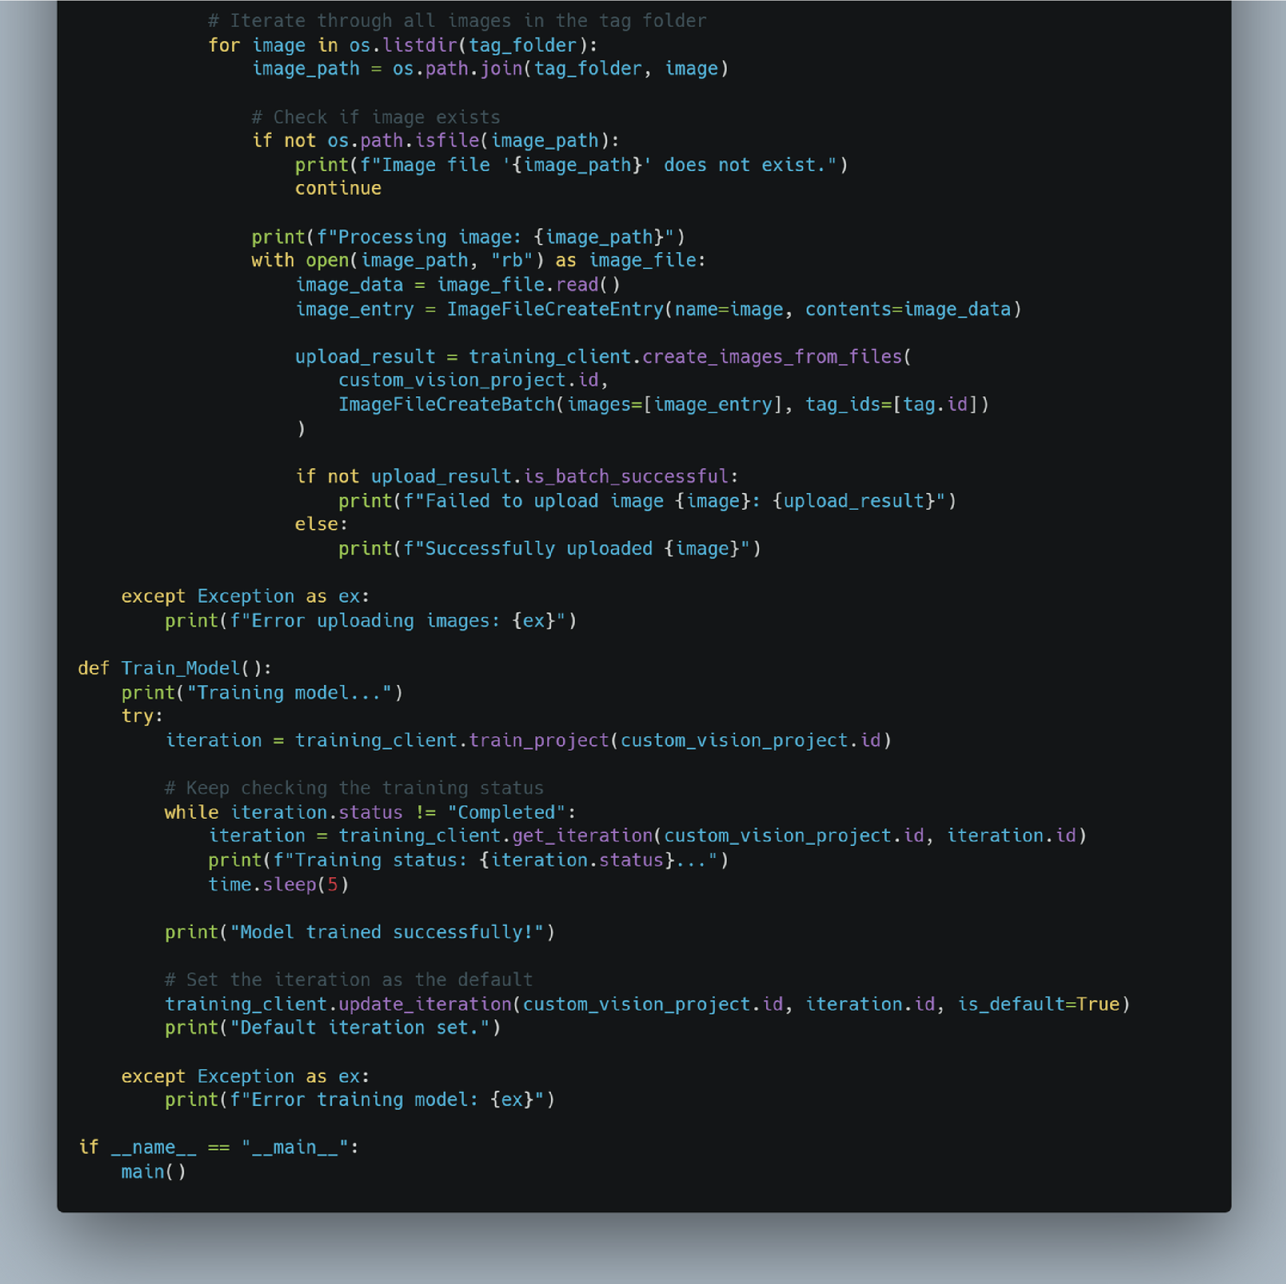

OUTPUT :-

